Princess Sumaya University for Technology

King Abdullah II Faculty of Engineering



**MICROPROCESSORS AND EMBEDDED**

**SYSTEMS PROJECT**

**“ WATER TANK”**

|  |  |  |
| --- | --- | --- |
| *Authors:* |  | *Supervisor:* |
| Leen Bilto 20210310  Jude Altheeb 20210415  Tala Hammouri 20210061 | IOT Eng.  Comp Eng.  Comp Eng. | Dr.Belal Sababha  Dr. Esam Qaralleh  Eng.Saad Al-zoubi |
|  | *Jan 14, 2025* |  |

***Abstract***

This project presents an automated dual-tank monitoring system using the PIC16F877A microcontroller, integrating ultrasonic sensors for water level monitoring and an NTC thermistor for temperature regulation. Key features include real-time data display on an LCD and automated control of a pump and solenoid valve to prevent overflow or depletion. The system demonstrates the practical applications of embedded systems in resource management, providing a cost-effective and reliable solution.

Contents

1 INTRODUCTION 1

1.1 OBJECTIVES 2

2 DESIGN 2

2.1 MECHANICAL DESIGN 2

2.2 ELECTRICAL DESIGN 3

2.3 SOFTWARE DESIGN 4

3 RESULTS 5

4 PROBLEMS AND RECOMMENDATIONS 8

5 CONCLUSIONS 8

6 REFERENCES 9

# INTRODUCTION

The advancement of embedded systems and automation has transformed resource management by enhancing efficiency and reducing waste across various industries. These systems automate critical tasks with precision and reliability, optimizing resource use and minimizing wastage, thereby promoting sustainability.

This project demonstrates the capabilities of the PIC16F877A microcontroller in developing an automated dual-tank water management system. By integrating ultrasonic sensors, temperature monitoring, and automated control mechanisms, the system efficiently manages water levels and monitors environmental conditions. This highlights the potential of microcontroller-based solutions in addressing water management challenges with simplicity and cost-effectiveness.

## OBJECTIVES

* **Demonstrate the role of embedded systems in water management** by automating water level monitoring and pump control using the **PIC16F877A microcontroller**.
* **Implement ultrasonic sensors** for real-time water level monitoring, ensuring automatic responses to prevent **overflow or depletion**.
* **Develop an automated control system** to regulate the **water pump (and solenoid valve, if applicable)** based on real-time water level data.
* **Design a user-friendly LCD interface** that provides **real-time system status updates**

for easy monitoring and operation.

* **Ensure stable power management** using a **12V DC supply with a regulated 5V output** for microcontroller operation.

# DESIGN

In this section we will show our design from different sides (Mechanical – Electrical – Software):

## MECHANICAL DESIGN

In our mechanical design, we focused on simplicity and efficiency. The system uses a compact setup to house components, ensuring neat wiring and accessibility. The water tanks are securely positioned, and the pump and solenoid valve are mounted for stable operation.

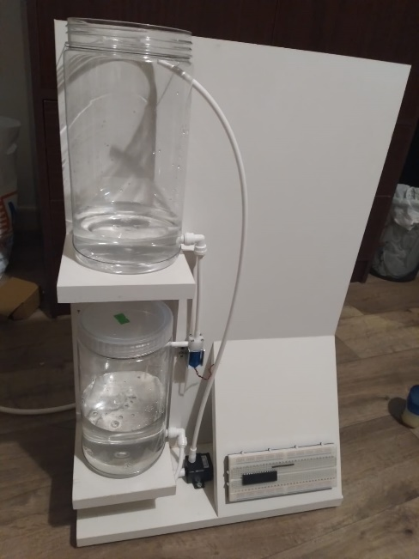

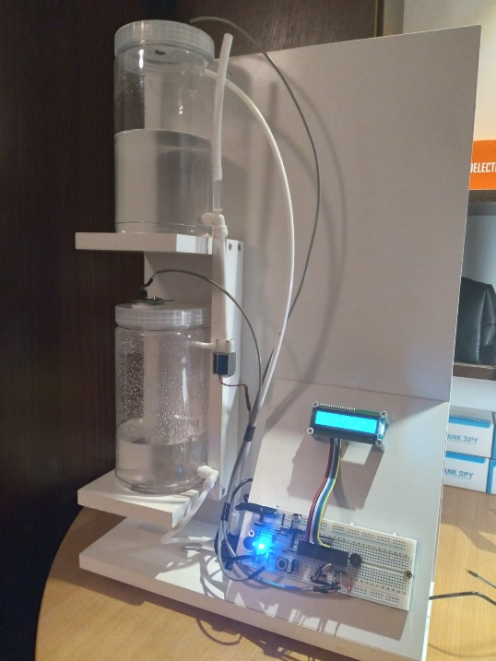 Figure 1. Mechanical Design (1)

Figure 2. Mechanical Design (2)

## ELECTRICAL DESIGN

In the electrical design, two ultrasonic sensors (HC-SR04) monitor water levels in both tanks, while an NTC thermistor measures temperature to activate a cooling fan when needed. A solenoid valve and water pump regulate water flow to prevent overflow. The PIC16F877A microcontroller processes sensor data and controls actuators, with an H-Bridge driving the fan motor. A 16x2 LCD provides real-time feedback on water levels and temperature. The system is powered by a 12V DC input regulated to 5V, ensuring efficient and reliable operation.

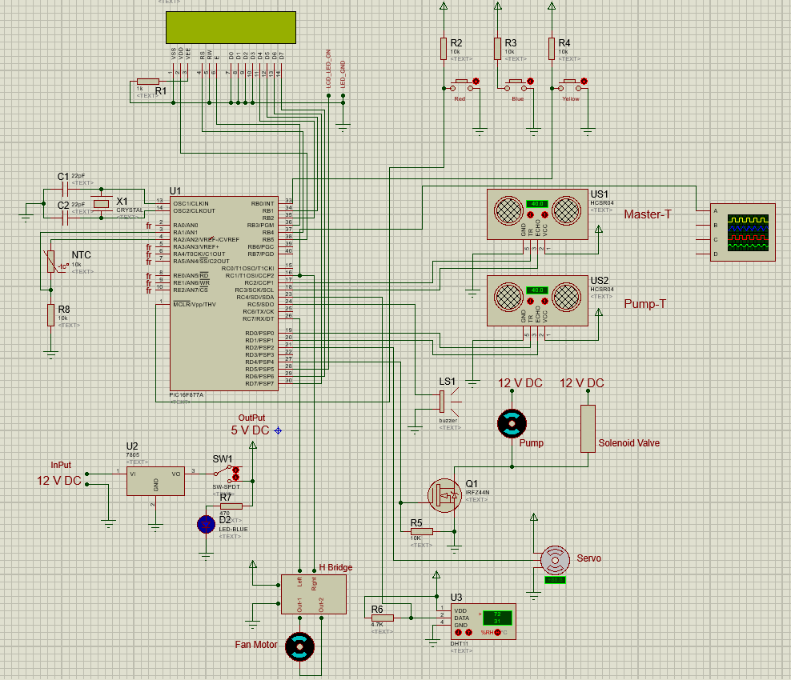

Figure 3. Electrical Design

## SOFTWARE DESIGN

This flow chart explains the flow of the program we used in our project.

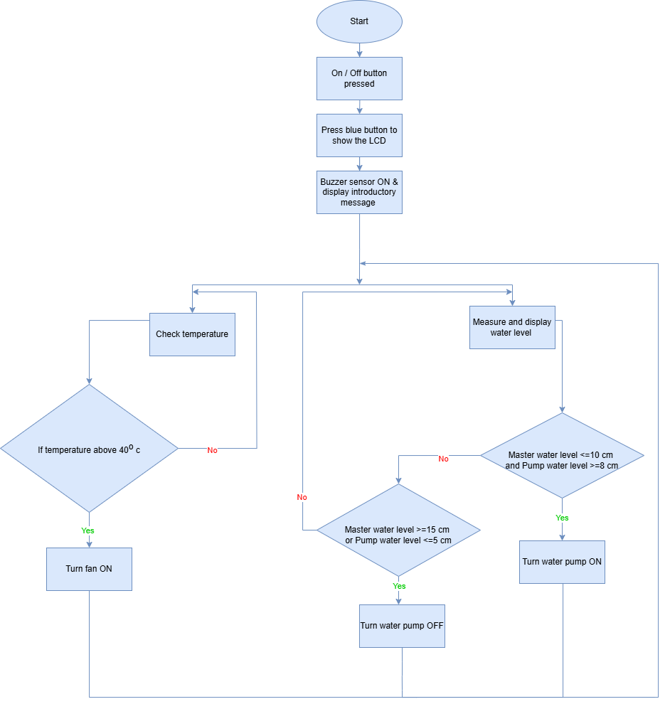

Figure 4. Software Design

# RESULTS

We were able to achieve all of the desired functionalities within this project, and this is our last prototype:

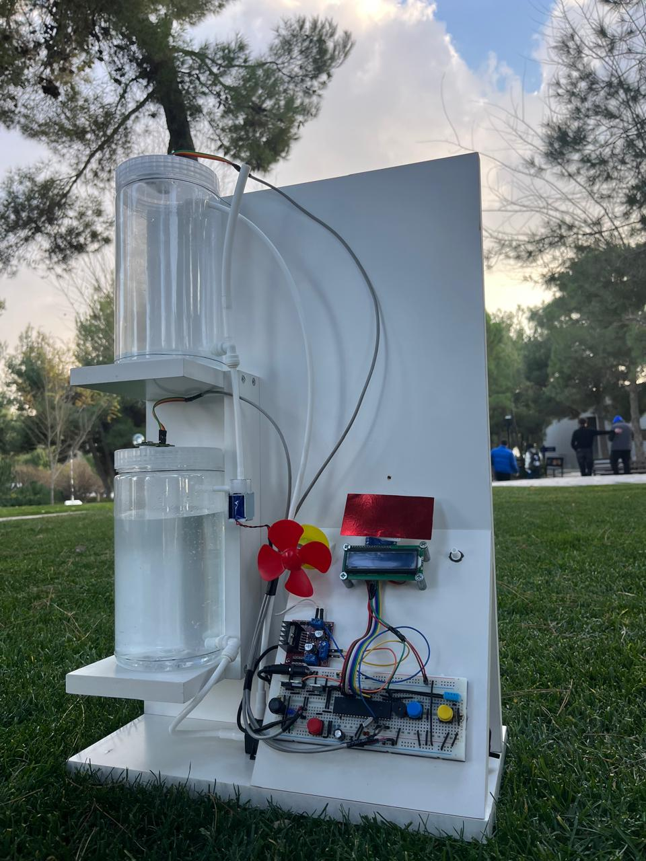

Figure 5. Final implementation (1)

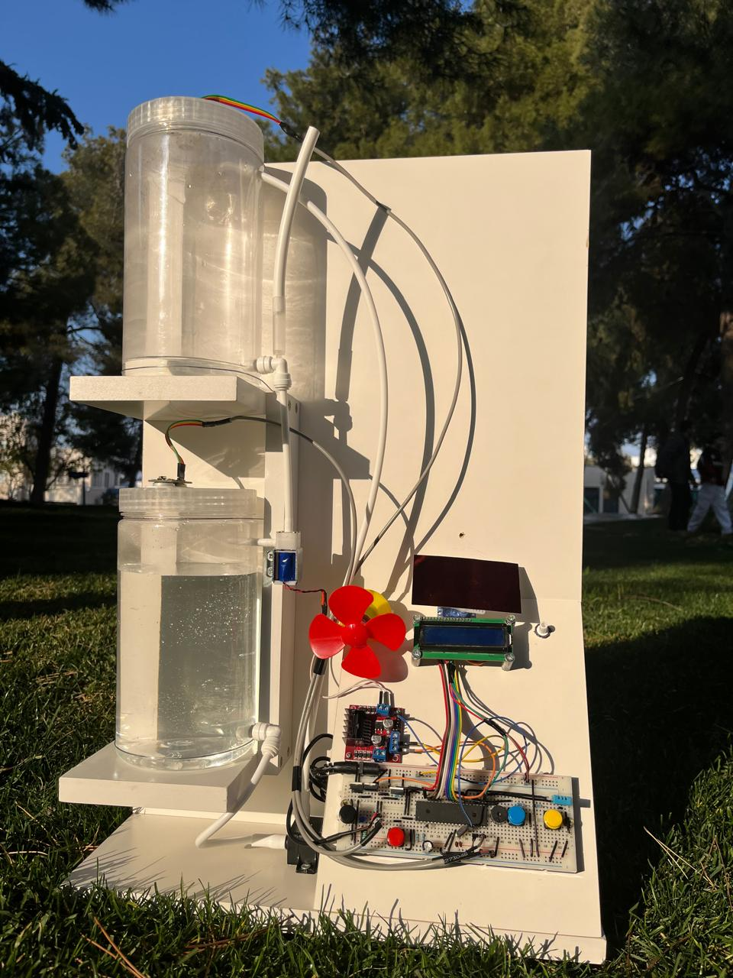

Figure 6. Final implementation (2)

**GitHub Link:** <https://github.com/jude189/Embedded_project>

**Youtube Link:** <https://youtube.com/shorts/ASQO5Lc3w0I?si=0XCm2P4LZ31bHDzB>

# PROBLEMS AND RECOMMENDATIONS

During the implementation of our dual-tank automated monitoring system, we faced several challenges that required troubleshooting and adaptation. Below are the key problems we encountered and how we addressed them:

1. The ultrasonic sensor initially did not provide accurate readings when used in a closed tank. We discovered that the sensor was designed for open environments and was unsuitable for confined or closed spaces, leading to false or inconsistent measurements. To solve this issue, we replaced it with a specialized ultrasonic sensor suitable for use in tanks or closed regions. This resolved the problem and improved water level detection accuracy.
2. We integrated a servo motor as a rotating cartoon figure that moves when the system is powered on, providing a visual indication of operation. However, calibrating the servo for smooth movement was challenging. After experimenting with different PWM signal settings, we adjusted the pulse width to achieve stable and accurate rotation.
3. Ensuring smooth and controlled water flow between the two tanks was another challenge. Initially, we faced delays and inconsistencies in pump activation due to sensor fluctuations. We resolved this by implementing software filtering and optimizing the threshold values for the ultrasonic sensors, ensuring accurate water level detection.

# CONCLUSIONS

This project demonstrated the potential of embedded systems in solving real-world challenges by automating water management processes. The successful integration of sensors, a microcontroller, and actuators resulted in a highly reliable system capable of real-time water level and temperature monitoring. By addressing critical design and implementation challenges, we developed a robust and efficient solution that meets the project's objectives.

Beyond the technical achievements, this project provided valuable insights into embedded system design, hardware-software interfacing, and real-time control. It serves as a foundation for further research and development in smart resource management. Future enhancements could include wireless connectivity, remote monitoring, and scalability improvements, making the system suitable for broader industrial and residential applications.

# REFERENCES

1. https://github.com
2. PSUT E-Learning